Experiment1.3

Student Name: Himanshu UID: 20BCS7944
Branch: CSE Section: 905/A
Semester: 6 Date of Performance: 01/03/2023
Subject Name: Data Mining Lab Subject Code: 20CSP-376

1) Aim:

Demonstration of association rule mining using Apriori algorithm.

2) Objective:

Creating association rules and using itemfrequency plot functions.
3) Code and Output:
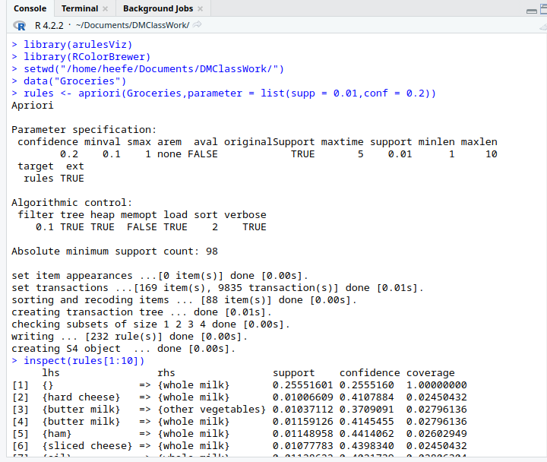

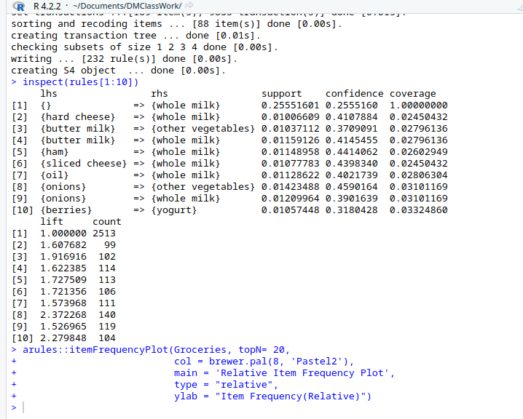

Code -
#Apriori algorithm

library(arules)
library(arulesViz)
library(RColorBrewer)
setwd("/home/heefe/Documents/DMClassWork/")
data("Groceries")
rules <- apriori(Groceries,parameter = list(supp = 0.01,conf = 0.2))

inspect(rules[1:10])

#using itemfrequency plot () function
arules::itemFrequencyPlot(Groceries, topN= 20,
col = brewer.pal(8, 'Pastel2'),
main = 'Relative Item Frequency Plot',
type = "relative",
ylab = "Item Frequency(Relative)")

